**4.Biomechanics**

The most attractive part for our e-bike is that it is able to provide assistance in proportion to how much the rider pedal which can save energy and rest feet for people without actually taking a break .For both e-bikes and ordinary bikes ,there are two same basic riding mechanics ,one is called the hip flexion which is the extension of hip and knee and with the degree around 70 and 140 between the quadriceps and calf muscles ,the other one is the knee flexion with the extension of muscles in the leg at position of 6 and 12 o’clock .

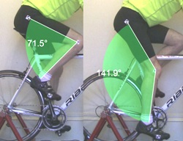

However , the big difference for the e-bike from the ordinary one is that the quadriceps and gluteus muscles will put less force to bring one of the pedal to the top at 12 0’clock position .Similarly , less downwards will be provided by the hamstring and calf muscles to the opposite of the pedal. The main effect for the big difference comes from the propulsion from the pedal motor in the rear part of the e-bikes which is also the main motivation of the bike. There is the comparison of different amount of force provided by human muscles to the pedal during riding e-bikes and ordinary bikes which are able to demonstrate the big difference for e-bikes, and is shown by figure X .

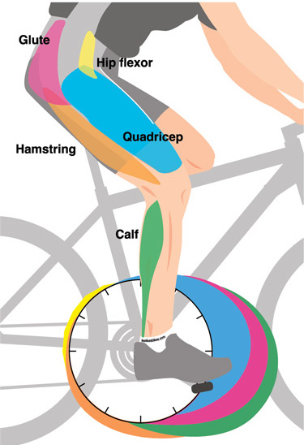

figure X

(Retrieved data in the figure from <https://www.quora.com/What-is-the-average-pedaling-force-applied-by-a-bicycle-rider>)

For upper part of human body , it is same for all types of bikes that one of muscles called abdominal muscle is responsible for cycler’s pine and ensuring the balance for the pelvis and spine .Moreover the muscles in the back and front of arms allow people to hold the handle bar . However , the difference for the e-bike designed by us is the up ride riding position frame with a cruiser handle bar which enable cycler’s spine to be straight rather than at an angle . In this up ride riding position , the abdominal muscle and the arm muscles will put less force in order to hold the posture which may avoid some possible physical problems in the back ,spine ,and neck of human .

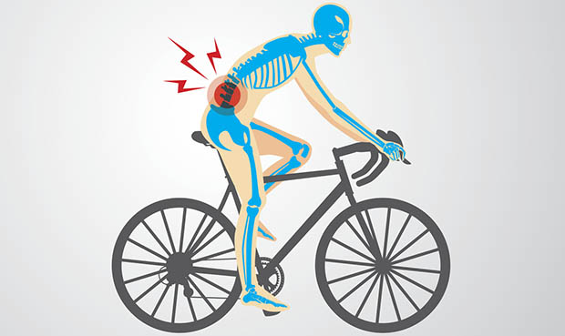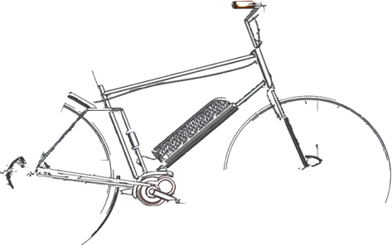

Reference:

Spine Health Institute. PROTECT YOUR NECK AND BACK WHILE BIKING:4 TIPS FOR SPINE-SAFE CYCLING .Retrieved 24th March 2018 from: <http://www.thespinehealthinstitute.com/news-room/health-blog/protect-your-neck-and-back-while-biking-4-tips-for-spine-safe-cycling>

Loving the bike .come.(2016).Benefits of cycling for the elderly: Cycle your way to health. Retrieved 24th March 2018 from: <http://lovingthebike.com/cycling-tips-and-information/benefits-of-cycling-for-the-elderly-cycle-your-way-to-health>